EVERY THURSDAY REGULAR TRASH PICKUP 7AM CURBSIDE
Pinkerton & Sons Rubbish Removal (207) 338-8330 (They also have large trash bins. Call for details)
Rimless tires (no bigger than 15”) can be put out with regular trash on Thursdays.
Paint can be filled with sand and sealed back up to be disposed of.
Spring Cleanup June 4, 2022 Fall Cleanup October 1, 2022
Acceptable Waste- White goods and household metals; Stoves, refrigerators, freezers, microwaves, washers, and dryers. Couches, chairs, tables, desks, shelves, rugs, linoleum, carpets and pads. Porcelain sinks/toilets. Window frames (with or without glass). Mattresses/Box springs. Metal gutters and gutter pipes. Bicycle frames.
Wood- Limited to one pile no bigger than 3ft x 3ft and single pieces no longer than 3ft. For larger quantities call the above number for a dumpster (at your expense).
Unacceptable Waste- Oil of any kind or quantity. Televisions and computer monitors. Sheetrock, asphalt shingles, brush, branches, tree clippings, garden or lawn debris.

The last Saturday of each month Prospect residents can dispose of the following items at the Stockton Springs Town Garage from 9am to Noon. No permit required. You can come by the office and pick up a reminder slip if needed.

Universal Waste Items Accepted:
Computers/Monitors/Televisions/Electronics

Fluorescent Lamps/Coated Lamps/Crushed Lamps/U-Lamps/HID Lamps

Batteries, Ballasts, Mercury Containing Devices, Waste Oil

Looking for more disposal options? (You may be required to pay.)
- Belfast Transfer Station 32 Little River Dr. Belfast, ME 04915
P: 207-338-1817 Tues, Thurs, Fri-Sat 8:00 AM – 3:30 PM,
- DM&J Waste Inc. – for construction debris
219 Stream Rd. Winterport, ME 04496 P: 207-223-4112

Recycling paint? www.paintcare.org or (855)–724–6809 for locations.

Every 3rd Wednesday of each month

(ZERO-SORT MEANS: No sorting recyclables into multiple containers.)
What CAN you recycle? | What you can NOT recycle?
Paper:
Cardboard/all boxes | Light bulbs
Newspaper & inserts/junk mail | Vinyl siding
Hardcover books | Windows/glass
Magazines/catalogs/phone books | Hypodermic needles or sharp objects
Paper bags | Paper napkins or towels
Office paper/window envelopes/office file folders | Bubble wrap/Styrofoam/Tyvek
Paper plates (clean)/pizza boxes | Food/frozen food bags/liquids
Paper shopping bags | Gas or propane containers
Empty drink & aseptic containers/empty milk & juice cartons | Alkaline or button-cell batteries
Gift boxes | Trash bags or household trash
Cereal boxes | No hazardous waste
Corrugated cardboard | No universal waste
Wrapping paper | NO PLASTIC SHOPPING BAGS!
Plastic:
All empty containers marked with#1-7 except Styrofoam
Water bottles (empty)
Detergent bottles (empty)
Milk jugs (empty)
Metal:
Empty tin cans (with or without labels)
Empty aerosol cans
Empty aluminum cans
Foil
Pots & pans
Glass:
All empty bottles & jars (all colors)

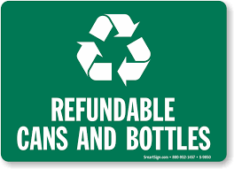
Redemption Centers

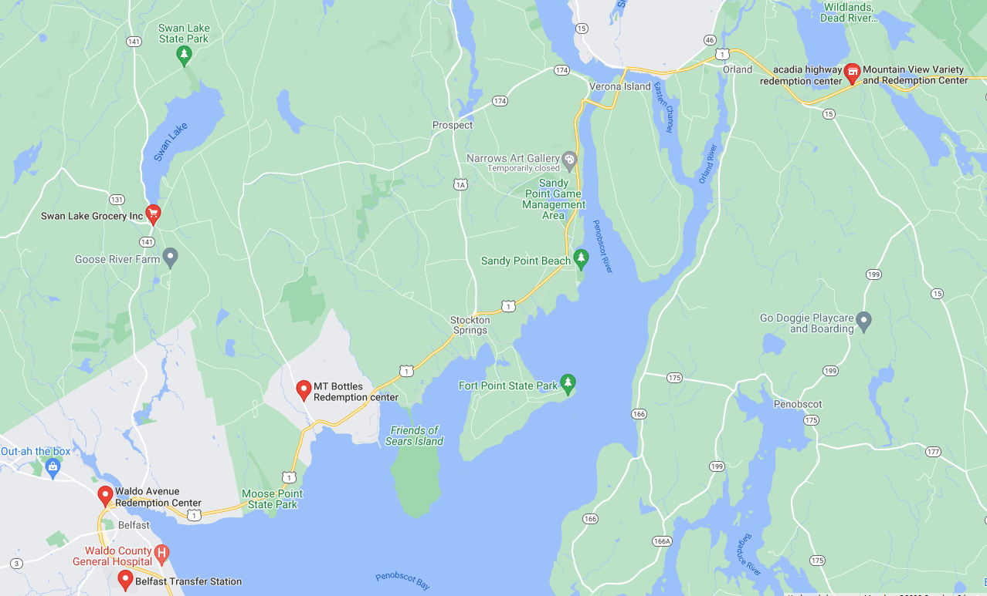
- Acadia Highway Redemption Center/ Mountain View Variety Phone: (207) 469-2014
960 Acadia Hwy, Orland, ME 04472 Everyday 9 am – 5 pm

- MT Bottles Redemption Center Phone: (207) 548-2363
65 Mt Ephraim Rd. Searsport, ME 04974 Mon - Sat 9 am – 5 pm

- Swan Lake Grocery Redemption Phone: (207) 338-4029
979 Swan Lake Ave. Swanville, ME 04915 Tues – Sun 9 am – 4:30 pm

- Waldo Ave Redemption Center Phone: (207) 338-2730
136 Waldo Ave. Belfast, ME 04915 Mon – Friday 8:30 am – 3:30 pm

