Saint James
Congregational Meeting
December 7, 2025

Senior Warden’s Report

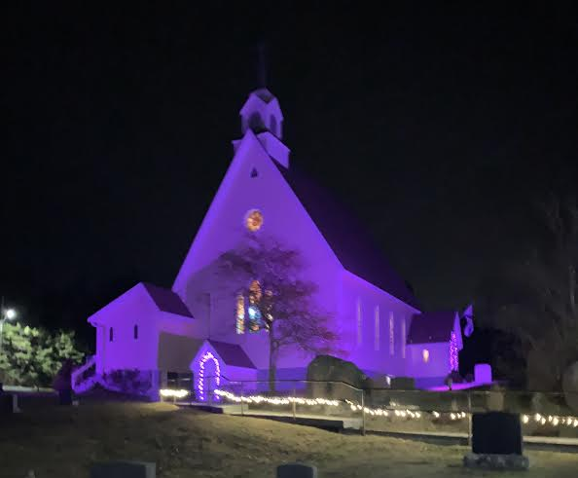
Acknowledging Advent and anti-GBV awareness

It has been a long time since we met for a congregational meeting. It was our intention to meet in the Spring on May 11, but circumstances did not permit. Then summer arrived….. That said, there has been a lot of activity at St. James ever since our AGM on January 26.

Worship: The Parish of French Village is a very active faith community! As the result of a successful test period, the worship schedule now features one 10AM Sunday service a week, each one at a different church. St.James hosts this Holy Communion service on the second Sunday of the month. Congregations often exceed 50 worshipers. We celebrate our shared ministry with the other three congregations by hosting a fellowship hour before service. We are blessed with the unfailing efforts of Sheila Nifort who never misses a beat in providing coffee and treats for each and every gathering.

Governance: Our Executive and Vestry Members continue to operate very successfully as a Team. The executive features three Co-Wardens: John Stone as Senior Warden, Shelly Hancock-Hurst as “Summer” Warden, and Drew Bethune as “Winter” Warden. Donna Pulsifer continues as our very conscientious Treasurer and Sheila Nifort as our ever-vigilant Secretary. Louise Christie and Dennis Crouse serve faithfully as Past Wardens. A large majority of the executive and vestry members serve on the Action Committee chaired by Drew Bethune. His report will be presented this morning.

You will all recall that we entered into a Strategic Planning Process two years ago. Most members of the Executive and the Vestry were involved. That committee, having functioned consistently and conscientiously through regularly scheduled meetings, morphed this year into the St. James Action Committee. Almost all of the activities that you will hear about at this meeting originate with the Action Committee which meets regularly on a monthly basis. This team approach is a far cry from the days when there were usually three meetings a year: the AGM, and (usually) a spring and fall congregational meeting.

Financial Stewardship: St.James is currently in a sound financial position. Savings and investments are the main reason. That said, we cannot overemphasize the thoroughly professional and conscientious way in which our meticulous Treasurer, Donna Pulsifer, has carried out her duties as Church Treasurer. It is worth noting that a) all but one of our regular offering contributors do so through PAR, and b) we only have one major scheduled fund-raiser for St.James and that is the pie-making (450!), the brainchild of Louise Christie. It was held on October 25. This year we thank Shelly Hancosck-Hurst

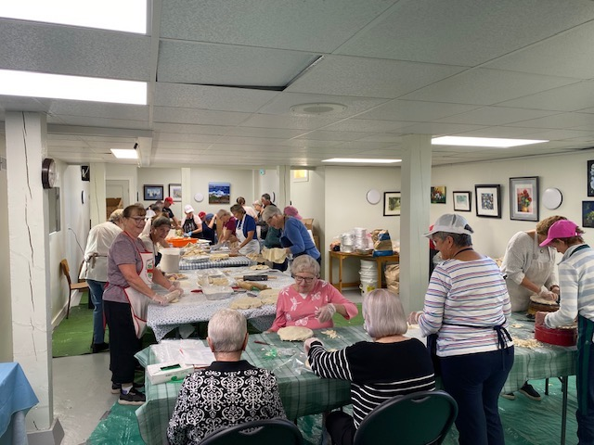
Pie-making Day

and Penny Gael for their organization and leadership roles! This truly community effort raised $3418.31 for St.James. Donna’s Treasurer’s Report will be presented this morning. Two points: 1) By virtue of a motion passed last year at Parish Council, all offerings made at all 4 churches go directly to the Parish Treasurer, Dorothy Dauphinee, who in turn attends to payments such as allotments. 2) Challenges do exist. The renewals of insurance contracts for the 4 churches are going to impose major increases for each and this will present a serious challenge to the Parish and to each congregation. The question will be: how is this to be handled?

Property Stewardship: The upkeep of the building and its efficient operation is never far from our minds. Overall The Yellow Church is in great shape. That said, the repair and painting of the steeple is still not done, for a number of reasons. The front entrance ramp needs a major repair. The (back-up) furnace has seen much better days and we have been advised that a replacement has to be found. We are not satisfied with the performance of the heat pump in the Hall. Throughout the building some minor electrical upgrades still need to be made.

The cemetery is in great shape thanks to the efforts of Louise Christie (The Community Fall Clean-up Day and grave lot registration) and Mel Brownell. Louise will offer a report this morning.

We continue to be eternally grateful to Gary and Matthew Veith for their free-will offering of plowing our parking lot and main entrance driveway.
Community: The model that we have been following for the last number of years focuses on Community. This means that we see St. James as an active member of the local and wider community. To demonstrate and achieve this, we want our church, its new Hall, the parking lot and adjacent area, to be seen as assets available for use by congregational members, as well as members and organizations within our local communities.

To that end, throughout the year, we host concerts in the main part of the church, and Coffee Houses in the Hall. Every Wednesday afternoon, except in the summer, we host James Games & Café from 2-4. Between 15 and 22 “gamers”, mostly Seniors, attend regularly. A seniors sewing group meets every two weeks. A group of Reiki practitioners meets every other month. Other users include an informal group of musicians, and special interest folks. We do not rent our space to our guests but rely instead on free-will offerings. A Church Usage report will be included in the Treasurer’s Report. It itemizes the groups/events that utilized St. James this past year.

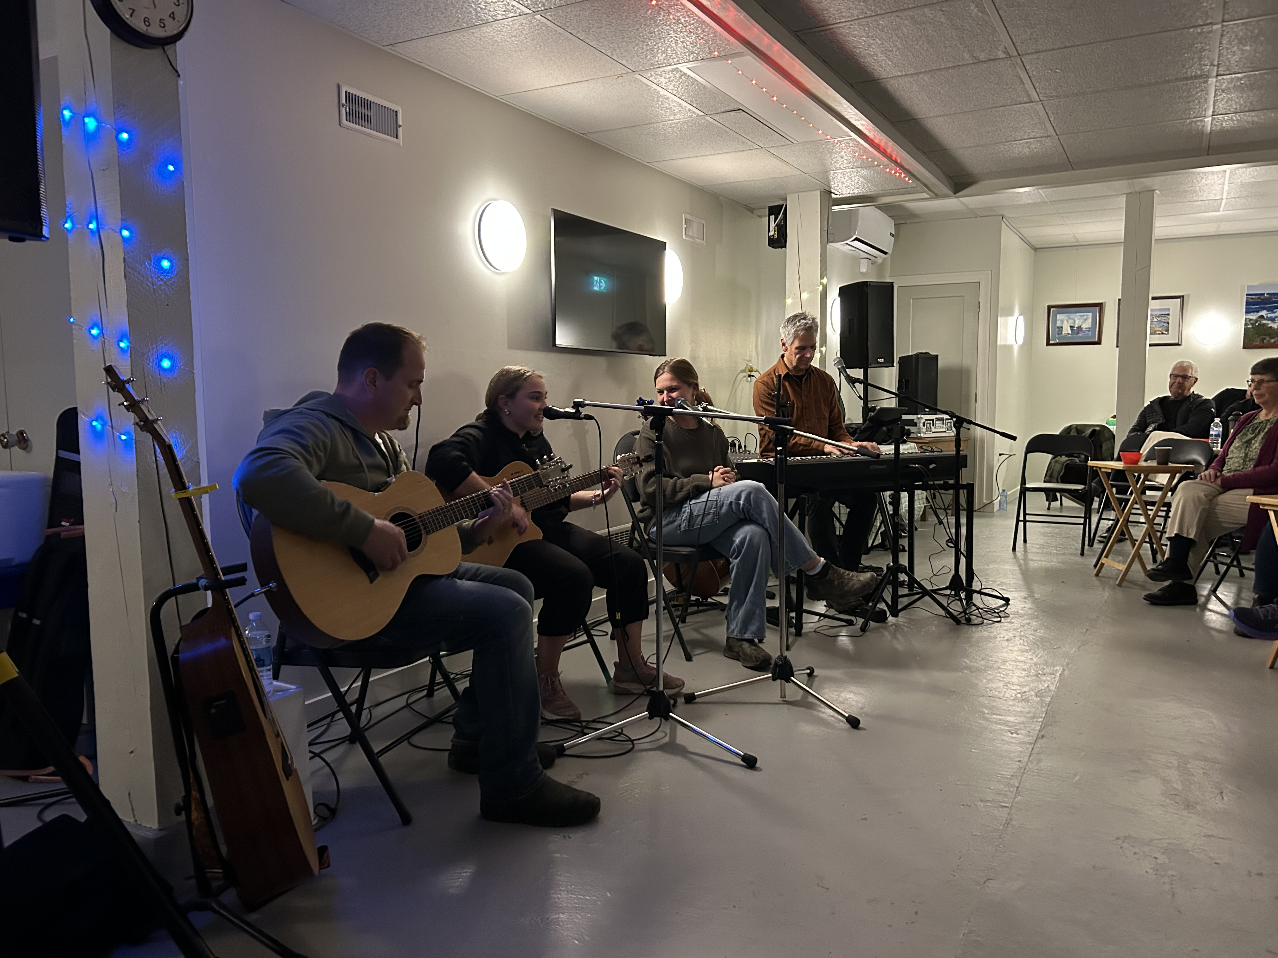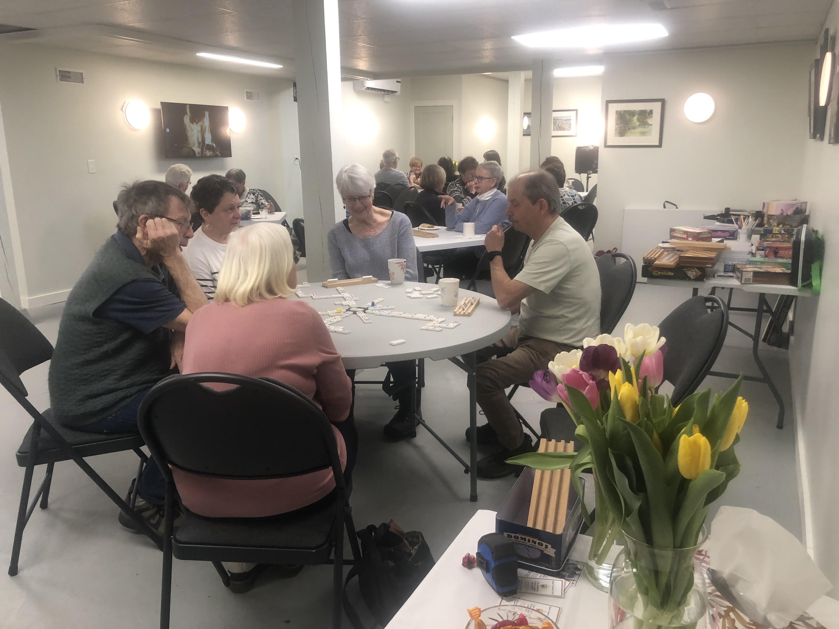
Coffee House; Gloria B. ,Kim D., The Christies James Games & Café

Outside, as part of our commitment to community, we continue to support Cool Bus Treats, and hold special community events like the annual cemetery clean-up, Easter Egg

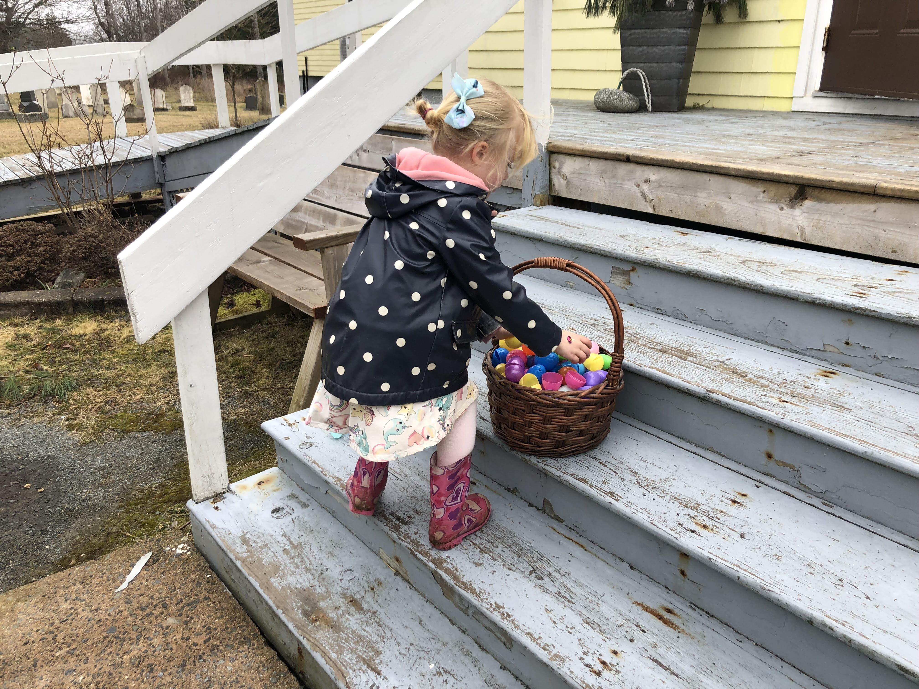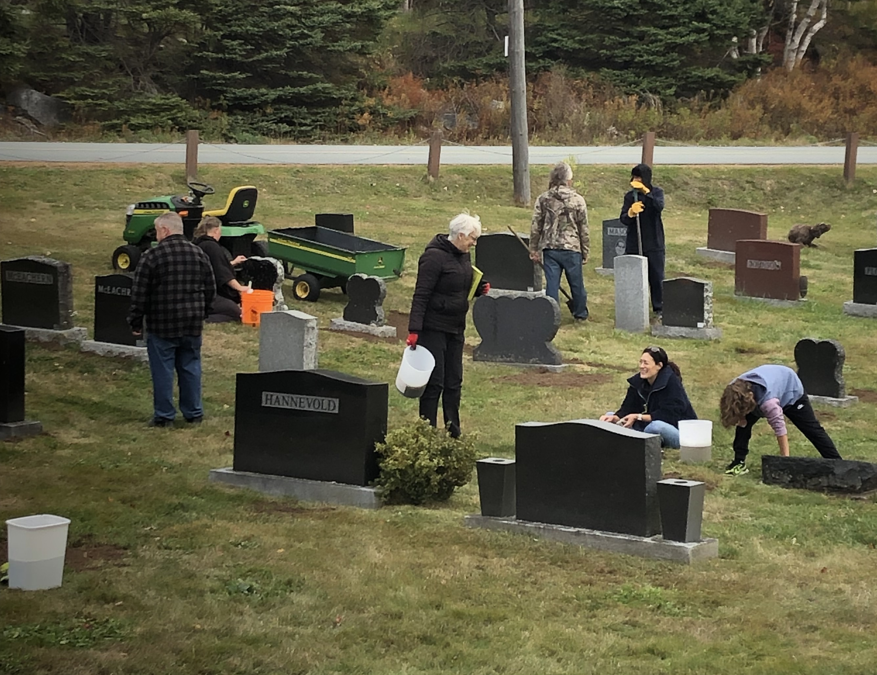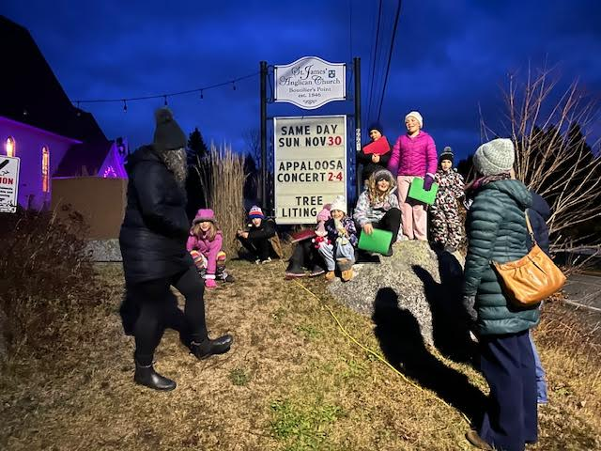
Easter Egg Hunt Cemetery Clean-up Tree-lighting, &Carol Sing

Hunt and the Tree-Lighting and Carol Sing for Advent. On our illuminated sign and flag staff, we invite passers-by to our activities and events, as well as to acknowledge and reflect on social issues such as poverty, racism, homelessness and issues related to identity.

We continue to be very willing and active members of the Parish of French Village and, as is the case with all its congregations, we feel truly blessed to have Archdeacon Brieanna Andrews as our priest, rector and spiritual leader.

Respectfully submitted, John Stone, Co-Warden

