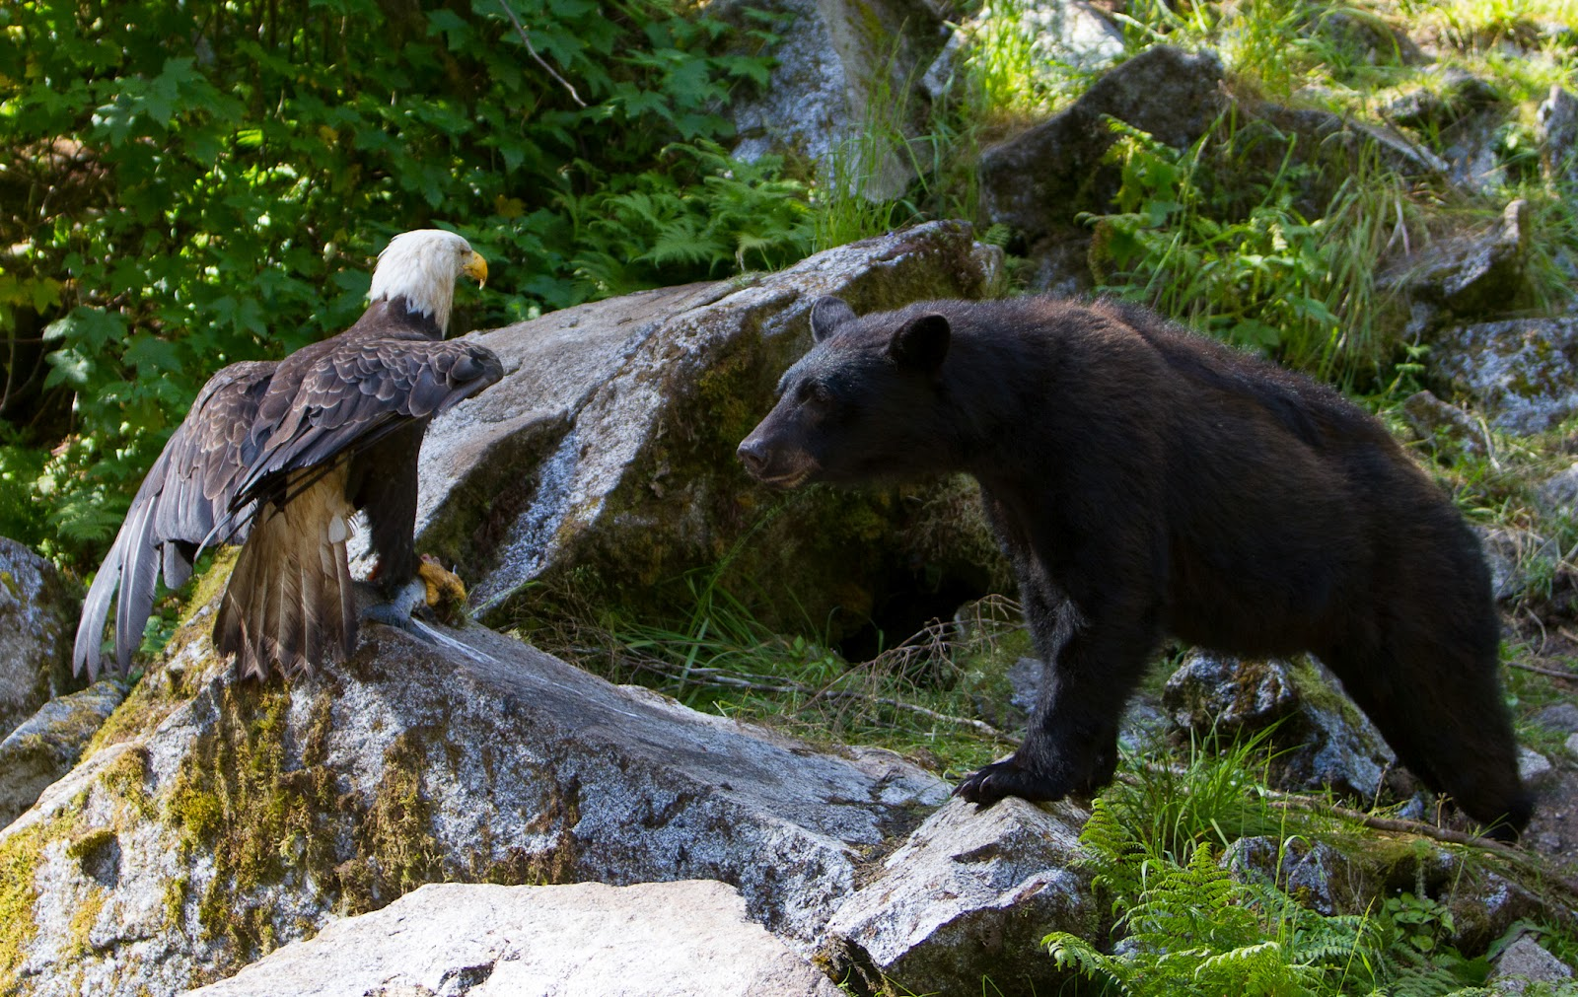

Indigenous Perspective!
Teachings / Sharing Circles
Every Monday: 2:30p.m. – 4:00p.m.
Limited Seats – Covid Protocol Followed
Masks and Social Distancing

No-one knows / understands where you are coming from.
Don’t know where to turn to.
Consider choices.

Peers / Grandmothers / Grandfathers / Ancestors / Creator
Ka’nikuhli:yo implements trauma-informed and strength-based cultural approaches to address community-based mental health and well-being concerns!
Geared to meet the needs of adults.
Contact: Ken Oliver, Coordinator
Phone: 519-672-0131 Ext 246
E-Mail: koliver@namerind.on.ca

