All Bulk Water Fill Locations
Effective January 1st, 2020, The Cartier Regional Water Coop no longer supplies a fill hose for water haulers. Customers require their own hose with a 3” Camlock Part C Type fitting to fill. It is also mandatory that all connections to the system for filling provide an “Airgap”.
Beginning September 1, 2020, a warning will be issued for the first offense. If not remediated, on a second infraction your account will be frozen until an “Airgap” is proven to be installed.
Please refer to the diagram below.
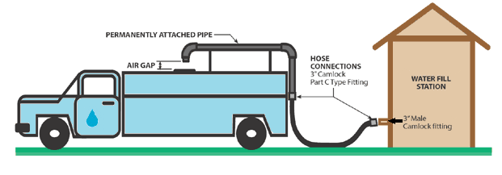
Please call 204-832-2555 with any questions or concerns
All Bulk Water Fill Locations
Effective January 1st, 2020, The Cartier Regional Water Coop no longer supplies a fill hose for water haulers. Customers require their own hose with a 3” Camlock Part C Type fitting to fill. It is also mandatory that all connections to the system for filling provide an “Airgap”.
Beginning September 1, 2020, a warning will be issued for the first offense. If not remediated, on a second infraction your account will be frozen until an “Airgap” is proven to be installed.
Please refer to the diagram below.
Please call 204-832-2555 with any questions or concerns

